AHAANA S

## Performance Chart:

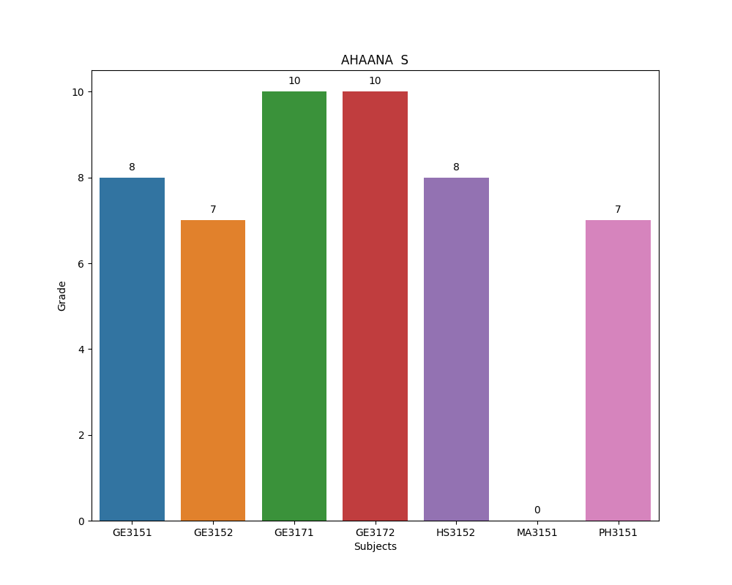

## Performance Details:

Student is get 'A+' grade in BS3171 subject.  
Student is get 'B+' grade in CY3151 subject.  
Student is get 'A' grade in GE3151 subject.  
Student is get 'B+' grade in GE3152 subject.  
Student is get 'O' grade in GE3171 subject.  
Student is get 'O' grade in GE3172 subject.  
Student is get 'A' grade in HS3152 subject.  
Student is get arrear in MA3151 subject.  
Student is get 'B+' grade in PH3151 subject.